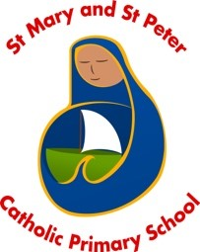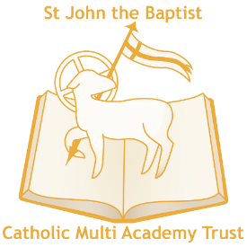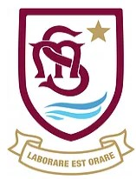

St Mary’s Catholic Primary School Lowestoft & St Mary and St Peter Catholic Primary School Gorleston (the ‘Coastal Catholic Schools’)
The Coastal Catholic Schools of Norfolk & Suffolk– part of St John the Baptist CMAT

St Mary and St Peter Catholic Primary School, East Anglian Way, Gorleston, Norfolk, NR31 6QY

St Mary's Roman Catholic Primary School, Kirkley Cliff, Lowestoft, Suffolk, NR33 0DG

Email: office@stmarysrcps.org office@smspprimary.norfolk.sch.uk

Websites: https://www.stmarysrcps.com/ https://smspprimary.co.uk/

Tel: 01502 565 384 (St Mary’s) 01493 445117 (St Mary & St Peter)

Executive Headteacher

L20 (£63,806) - L26 (£73,903), starting range L20 – L23

Full Time - Required for January 2019, or as soon as possible afterwards

St Mary and St Peter Catholic Primary School and St Mary’s Catholic Primary School are two vibrant Roman Catholic Primary Schools situated in Gorleston and Lowestoft respectively on the east coast of Norfolk and Suffolk. They are within easy travelling distance from each other and share many characteristics, such as size, ethos, a close working relationship and similarity in both opportunity and challenges. Due to the promotion of both current Headteachers we are excited to offer an Executive Headship across the two schools, with the full support of the Trust and Local Governing Bodies. Staff, parent and Governors are very proud of our two schools and they are welcoming and delightful places to grow and learn.
We are committed to the belief that everyone is treated with fairness, justice, compassion, inclusiveness, love, respect and ensure all pupils have the opportunity for a quality education in a spiritual environment.
Both schools were founding members in May 2016 of the St John the Baptist Catholic Multi Academy Trust and the successful candidate will have the opportunity to shape both the schools and contribute to the future success of the Trust. Our schools have separate Local Governing Bodies but have long established joint working and aspire to share more leadership, staffing, CPD and vision to be the best possible environments for learning, growth and spiritual development.
This is an exciting opportunity for someone who wishes to develop their career in a senior post not often available at Primary level as the successful candidate will be joining a strong Multi Academy Trust committed to staff development and stable schools which have great potential to become even stronger in the near future.

The Directors and LGB are seeking to appoint a well-qualified, ethos driven and capable senior leader to take the helm of our happy and community centred schools. The successful candidate will have a proven track record of success as a senior leader and will commit themselves to further improving Teaching and Learning within both schools.

We welcome applications from exceptional candidates at the cusp of school Leadership, as well as strong established leaders.

Applications are sought from practising Catholics who will develop further our Catholic ethos.

For an application form and further details please visit our MAT website – www.stjohnthebaptist-cmat.org.uk or email or visit either schools’ website. Preliminary visits to the schools are welcome by arrangement with the current Headteachers who are moving onwards and upwards – please contact the schools individually - or alternatively the CEO of the Trust Mr Brian Conway on 01603 611431.

Closing date for applications: Wednesday 19th September 2018 at midday.
Interview dates: Tuesday and Wednesday 25th and 26th September 2018.
Application forms should be returned to recruitment@sjbcmat.org.uk or by post to John Eady, Operations Manager, St John the Baptist CMAT, Surrey Street, Norwich, NR1 3PB.
Applicants should be practicing Catholics supportive of our ethos. St John the Baptist CMAT welcomes applications from members of minority ethnic communities and those with disabilities. The MAT is committed to safeguarding and promoting the welfare of children and young people and expects all staff and volunteers to share this commitment. You will be subject to DBS checks along with relevant employment checks.

