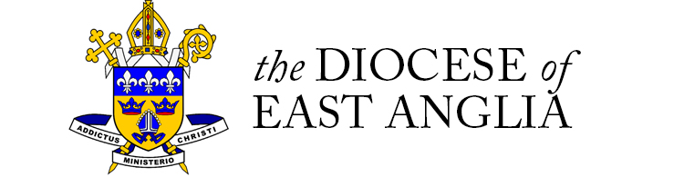

Application for Admission to Sacred Heart Catholic

VA Primary School
For admission from September 2019

CHILD’S DETAILS

Child’s Surname | Child’s Forename(s): | Male / Female

Date of birth (dd/mm/yy): | Current school year group: | Does your child have an Education Health & Care Plan
 |  | Yes / No

Is your child adopted, in the care of a Local Authority, subject to a Special Guardianship Order or subject to a Residence Order? | Yes / No | Please Name Responsible Authority

Child’s Home Address:

Address: ………………………………………….……………………………………..

Postcode

Tel | Email

Name and address of current or last school:
Tel No:

Is the child still attending? | Yes / No

If not, what was the last date of attendance at school:
Was the child permanently excluded? | Yes / No

Languages spoken at home:

PARENT/CARER DETAILS

First name: | Title: (Mr,Mrs etc.) | Surname:
What is your relationship to the child? |  | Do you have Parental Responsibility?
 |  | Yes / No

Address if different to the child’s address.

Address …………………………………………………………………………………..

…………………………. ………………………………………………………………..

Postcode

SIBLINGS

Does the child have a brother or sister who you wish to attend Sacred Heart RCVA Primary School in 2019/20? Yes / No
If Yes, please provide details below:

Name | Date of birth | Current school

You will need to complete a separate application for each child you are seeking a school place for.

When is the place required :

Are you applying on the basis of faith? Yes / No

If yes please state your faith:
If your child is a Catholic please state date of Baptism:
Place / Parish of Baptism

Please enclose a copy of your child’s Catholic Baptismal Certificate. We cannot recognise children as being Catholic without this evidence.

If your child is a member of an Eastern Christian Church, or of another Christian denomination, please provide a copy of their Baptismal certificate.

If your child is receiving instruction in preparation for entering the Catholic Church through Baptism (i.e. a catechumen), or is a member of another faith, please provide a letter from your religious leader/minister.

You are invited to give further reasons for your preference for Sacred Heart Catholic VA Primary School:

Please note that we may contact your child’s current school to request further information in connection with your application.

PLEASE NOTE: If you wish to apply for other state funded schools please contact Norfolk County Council (www.norfolk.gov.uk/admissions

PARENT’S DECLARATION

I certify that, to the best of my knowledge, the information I have given is correct. I understand that if false information is provided any offer of a school place will be withdrawn.
Parent/Carer signature:

Date:

For full information regarding Sacred Heart Catholic VA Primary School’s admission policy see: www.rcdea.org.uk/sacredheart

The information collected on this application form will be subject to the General Data Protection Regulations and the Data Protection Act 2018. We will hold it for use on processing your child’s admission. It may be shared with the Department for Education, Norfolk County Council and local Health Authorities & Trusts. Data will also be passed to staff at Sacred Heart Catholic VA School to enable them to manage the admission of your child. All information given will be held in strictest confidence and maintained in accordance with data protection legislation.

Please return this form and any supporting information to:

Diocesan Schools’ Office
21 Upgate
Poringland
Norwich
NR14 7SH

Email: ssc@rcdea.org.uk

