**Parish Posada Journey Notes**

**Thank you for volunteering to set this up for your parish this Advent.**

This is an informal parish friendship and prayer circle based on the Mexican tradition of a young couple visiting all the houses in a parish re-enacting Mary and Joseph’s journey. We have a statue which travels around the parish and stays overnight in different homes throughout Advent.

All you need to do is to ask your parish priest for the resources pack he has been sent. Then:

1. Put up the poster;

2) Put something in the newsletter/bulletin - maybe cut and paste the introduction above;

3) Get people to sign up on the weekends in November. Many people know the idea as this has become a tradition for many parishes. However, you do need to ensure that new folk get the chance and try to ensure it isn't just the regulars visiting their friends. People need some encouragement to sign up to go to a stranger’s house. Don't just leave the sheet out. This is a chance for people to talk informally to others about their faith as they sign up and plan the visit.

4) Arrange with your parish priest to give the statue to the first family at Mass on **1st Sunday of Advent (2nd December).** There is a sheet with a suggested blessing in the resources pack;

5) The statue is taken by one family on to the next home. I have found that with a bit of encouragement people can do this themselves so you shouldn't need to be involved.

*All people need to do is contact the people on the sheet and arrange to tak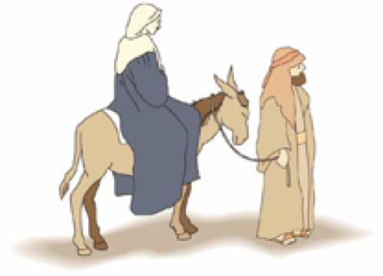e the statue to their home.

*The hosting is very simple and not elaborate. The hosts might like to put out a little table and candle or similar.

*A cup of tea and a mince pie or a biscuit is all that people will expect.

*The statue comes with a sheet of prayers that people can say if they want. It’s worth photocopying several times so a group can use the prayers when they gather and maybe laminating the sheets to help them last the whole season.

6) As not everyone can have the statue, it’s a good idea for hosts to invite parishioners living locally or neighbours. This is lovely way to share our faith but you may need to encourage people. Sometimes small Mass locations don’t get included. Maybe you can think of a way to include them. It could help build bridges across the parish. Maybe someone could take it to a residential care home …

7) As there are a lot of single older people, one idea might be to book the statue to come to a coffee morning or similar that the parish already holds so everyone gets to see it.

8) If there’s a gap it doesn’t matter- the lucky family gets to keep it for two nights. There will be a little flurry of interest when people have seen the statue leave church on the first Sunday of Advent and gaps will get filled.

9) Arrange for the statue to return to church on Christmas Eve. It is nice to have it come back for morning Mass depending on your timetable.

* People love the statue but it is breakable and not a toy: some care needs to be taken with it.